select * from Loan_data;

SELECT COUNT(id)as Total_applications from Loan_data;

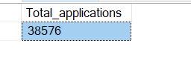

#MONTH TO DATE APPLLICATIONS

SELECT COUNT(id)as MTD_Applications from Loan_data

WHERE MONTH(issue_date)=12 AND YEAR(issue_date)=2021;

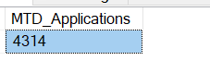

#Previous_MTD_Applications

SELECT COUNT(id)as MTD_Applications from Loan_data

WHERE MONTH(issue_date)=11 AND YEAR(issue_date)=2021;



#Total funded amount

Select SUM(loan_amount) as total_amt_funded from Loan_data;

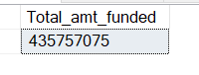

# MTD total funded amount

Select SUM(loan_amount) as MTD_total_amt_funded from Loan_data

WHERE MONTH(issue_date)=12 AND YEAR(issue_date)=2021;

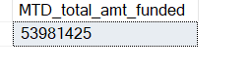

#Previous MTD Total funded amount

Select SUM(loan_amount) as PMTD_Total_amt_funded from Loan_data

WHERE MONTH(issue_date)=11 AND YEAR(issue_date)=2021;

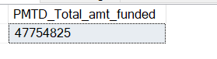

#Total amount received

select SUM(total_payment) as Total_amt_received FROM Loan_data;

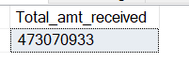

#MTD Total amount received

SELECT SUM(total_payment) as MTD_total_amt_received FROM Loan_data

WHERE MONTH(issue_date)=11 AND YEAR(issue_date)=2021;

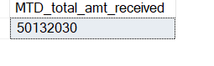

#Average interest rate

select ROUND(AVG(int_rate),4)*100 as average_int_rate from Loan_data;

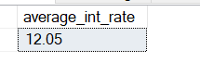

#MTD average interest rate

select ROUND(AVG(int_rate),4)*100 as MTD_average_int_rate from Loan_data

WHERE MONTH(issue_date)=12 AND YEAR(issue_date)=2021;

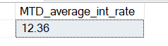

#PMTD average interest rate

select ROUND(AVG(int_rate),4)*100 as PMTDaverage_int_rate from Loan_data

WHERE MONTH(issue_date)=11 AND YEAR(issue_date)=2021;

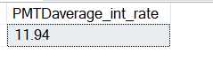

#average dti

select ROUND(AVG(dti),4)*100 as Average_dti from Loan_data;

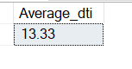

#MTDaverage dti

select ROUND(AVG(dti),4)*100 as MTDaverage_dti from Loan_data

WHERE MONTH(issue_date)=12 AND YEAR(issue_date)=2021;

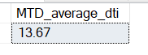

#PMTDaverage dti

select ROUND(AVG(dti),4)*100 as PMTDaverage_dti from Loan_data

WHERE MONTH(issue_date)=11 AND YEAR(issue_date)=2021;

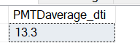

#Good_loan_percentage

SELECT

(COUNT(CASE WHEN loan_status = 'Fully paid' OR loan_status = 'Current' THEN id END))*100/

COUNT(id) AS Good_loan_percentage from Loan_data;

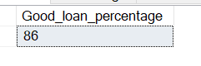

#Good_loan applications

select COUNT(id) as good_loan_applications from Loan_data

where loan_status='fully paid' OR loan_status ='Current';



#Good loan funded amount

select SUM(loan_amount)as good_loan_funded_amount from Loan_data

WHERE loan_status = 'Fully paid' OR loan_status ='Current';

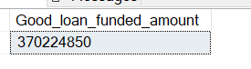

#Good loan received amount

select SUM(total_payment)as good_loan_received_amount from Loan_data

WHERE loan_status = 'Fully paid' OR loan_status = 'Current';

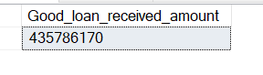

Bad loan

#Badloan applications percentage

select

(COUNT(case when loan_status ='Charged Off' THEN id END))*100/

COUNT(id) as bad_loan_percentage from Loan_data;

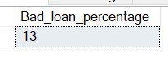

#Bad Loan Applications

select COUNT(id) AS Bad_loan_Applications from Loan_data

WHERE loan_status='Charged Off';

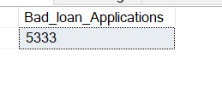

#Bad Loan funded amount

select SUM(loan_amount)as Bad_loan_funded from Loan_data

WHERE loan_status='Charged Off';



#Bad Loan amount received

select SUM(total_payment) as Bad_loan_amt_received from Loan_data

WHERE loan_status='Charged Off';

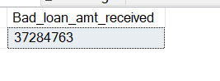

#Analysis by Loan status

select

loan_status,

COUNT(id)as total_applications,

sum(loan_amount)as total_amt_funded,

sum(total_payment) as total_amt_received,

AVG(int_rate*100)as interest_paid,

AVG(dti*100) as Dti_paid,

sum(total_payment)-sum(loan_amount) as difference

from loan_data

group by loan_status;

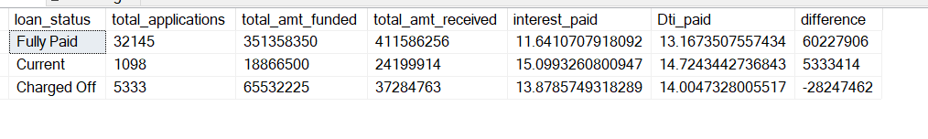

#MTD Analysis by Loan status

Select loan_status,

COUNT(id)as mtdtotal_applications,

sum(loan_amount)as mtdtotal_amt_funded,

sum(total_payment) as mtdtotal_amt_received,

AVG(int_rate*100)as mtdinterest_paid,

AVG(dti*100) as mtdDti_paid,

sum(total_payment)-sum(loan_amount) as mtddifference

from loan_data

where MONTH(issue_date)=12

group by loan_status;

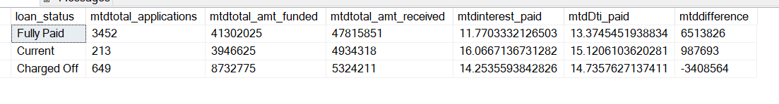

select

MONTH(issue_date),

DATENAME(MONTH,issue_date),

COUNT(id)as mtdtotal_applications,

sum(loan_amount)as mtdtotal_amt_funded,

sum(total_payment) as mtdtotal_amt_received,

AVG(int_rate*100)as mtdinterest_paid,

AVG(dti*100) as mtdDti_paid,

sum(total_payment)-sum(loan_amount) as mtddifference

from loan_data

group by MONTH(issue_date),DATENAME(MONTH,issue_date)

ORDER BY MONTH(issue_date);

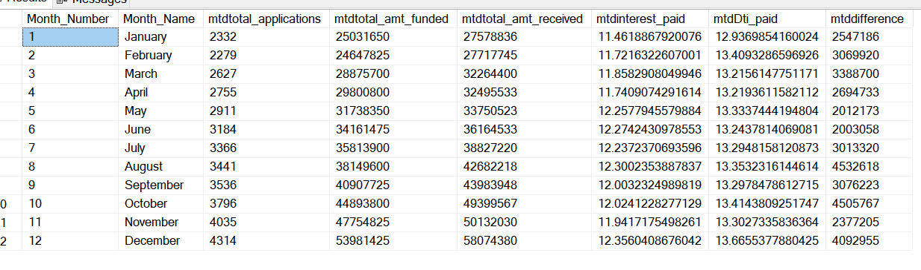

**Regional analysis by state**

select address_state,

COUNT(id)as mtdtotal_applications,

sum(loan_amount)as mtdtotal_amt_funded,

sum(total_payment) as mtdtotal_amt_received

from loan_data

group by address_state

ORDER BY address_state

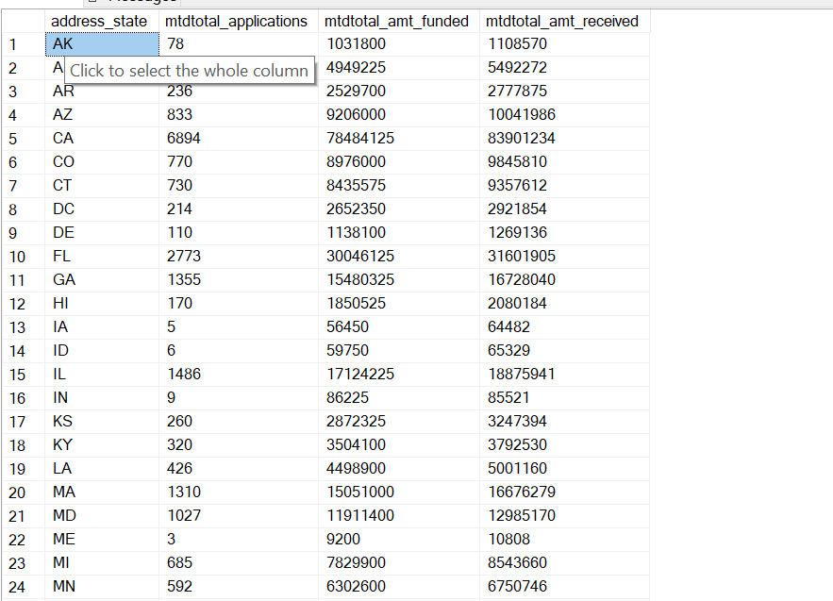

select address_state,

COUNT(id)as mtdtotal_applications,

sum(loan_amount)as mtdtotal_amt_funded,

sum(total_payment) as mtdtotal_amt_received

from loan_data

group by address_state

ORDER BY sum(loan_amount) desc

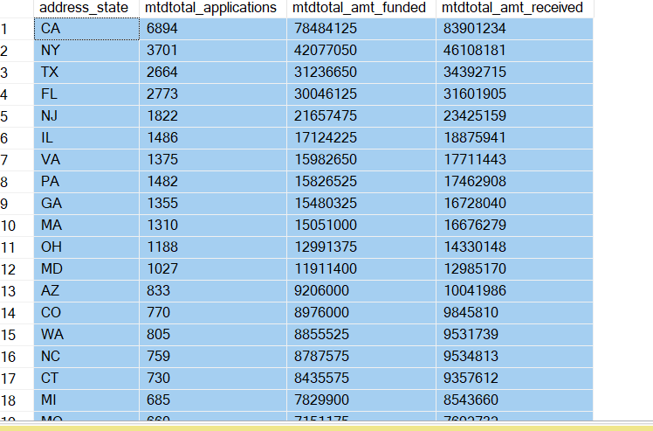

select term,

COUNT(id)as mtdtotal_applications,

sum(loan_amount)as mtdtotal_amt_funded,

sum(total_payment) as mtdtotal_amt_received

from loan_data

group by term

ORDER BY term

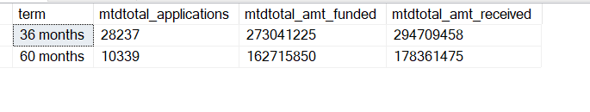

Analysis by employee length

select emp_length,

COUNT(id)as mtdtotal_applications,

sum(loan_amount)as mtdtotal_amt_funded,

sum(total_payment) as mtdtotal_amt_received

from loan_data

group by emp_length

ORDER BY emp_length

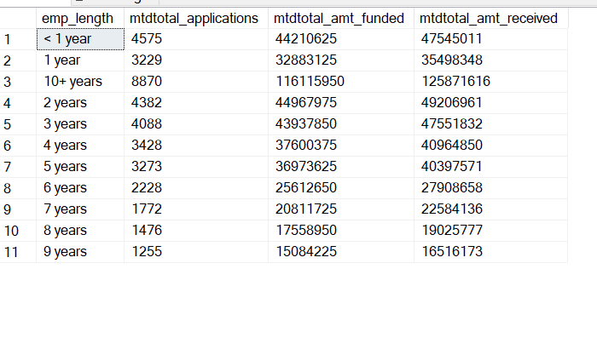

Analysis by purpose

select purpose,

COUNT(id)as mtdtotal_applications,

sum(loan_amount)as mtdtotal_amt_funded,

sum(total_payment) as mtdtotal_amt_received

from loan_data

group by purpose

ORDER BY COUNT(id)

Analysis by PURPOSE

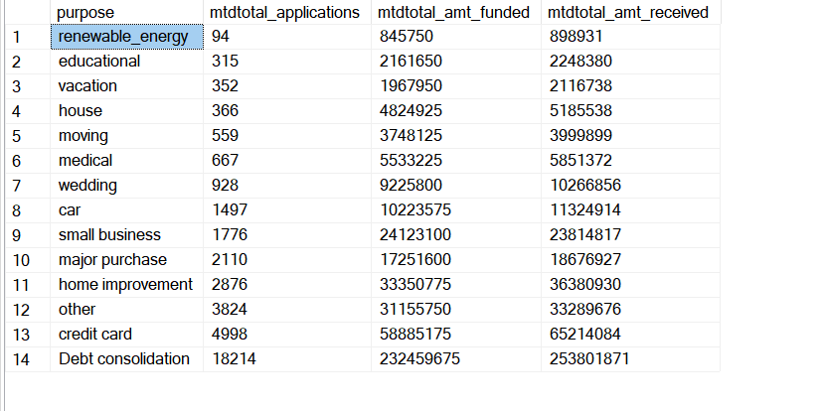

select purpose,

COUNT(id)as mtdtotal_applications,

sum(loan_amount)as mtdtotal_amt_funded,

sum(total_payment) as mtdtotal_amt_received

from loan_data

group by purpose

ORDER BY COUNT(id)desc

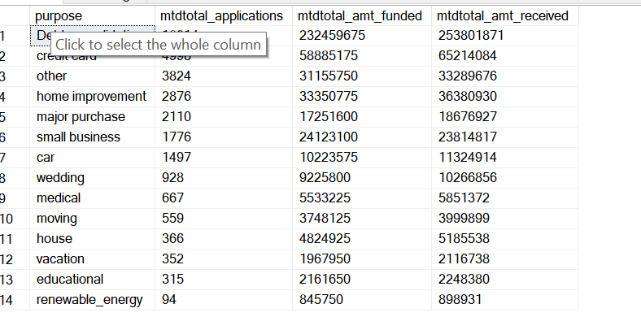

**ANALYSIS BY HOME OWNERSHIP**

select home_ownership,

COUNT(id)as mtdtotal_applications,

sum(loan_amount)as mtdtotal_amt_funded,

sum(total_payment) as mtdtotal_amt_received

from loan_data

group by home_ownership

ORDER BY COUNT(id)desc

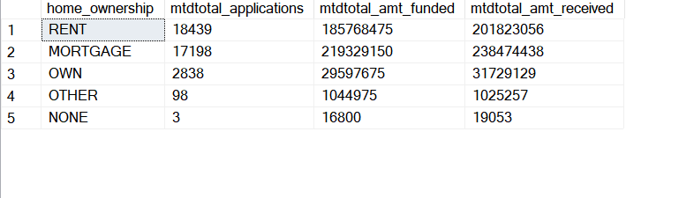

**GRID VIEW**

select * from loan_data;

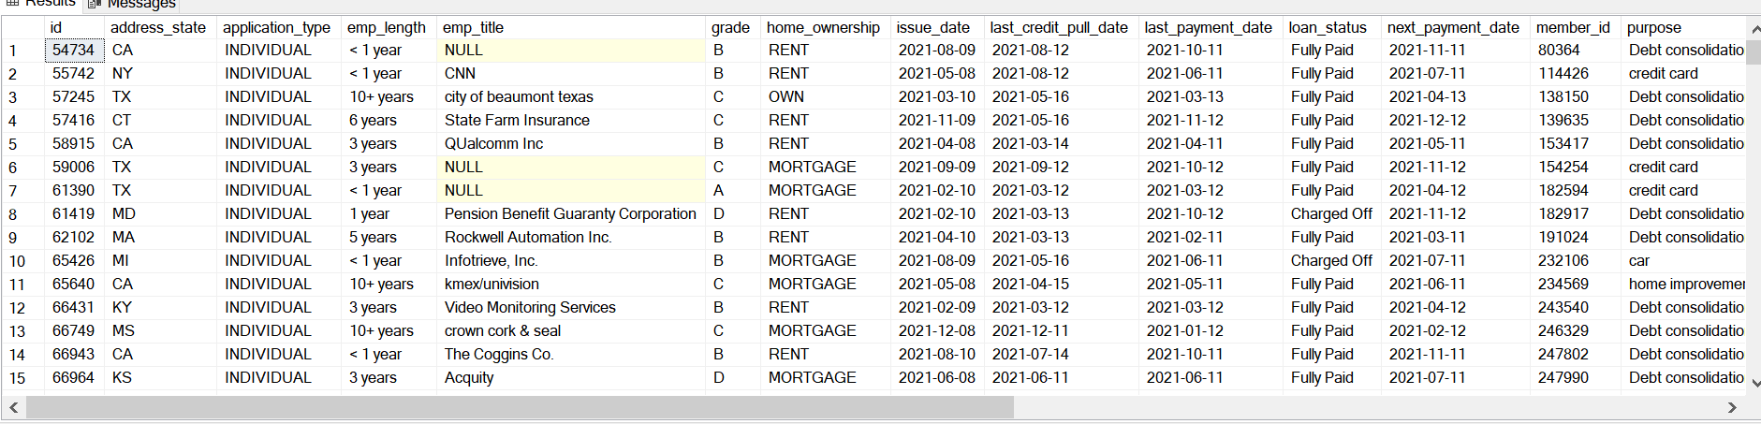

select home_ownership,

COUNT(id)as mtdtotal_applications,

sum(loan_amount)as mtdtotal_amt_funded,

sum(total_payment) as mtdtotal_amt_received

from loan_data

WHERE grade ='A'

group by home_ownership

ORDER BY COUNT(id)desc

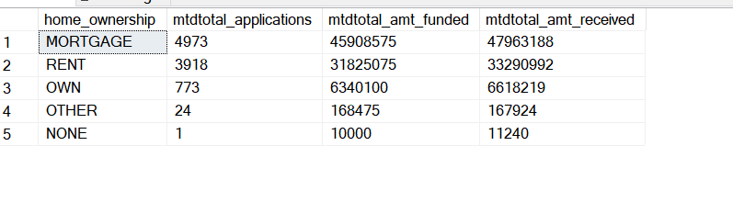

select home_ownership,

COUNT(id)as mtdtotal_applications,

sum(loan_amount)as mtdtotal_amt_funded,

sum(total_payment) as mtdtotal_amt_received

from loan_data

WHERE grade ='A' AND address_state ='CA'

group by home_ownership

ORDER BY COUNT(id)desc

